Friday practical Preparation

Create the following tables following the stated specifications;

Table 1: Employee

EmployeeID INT PRIMARY

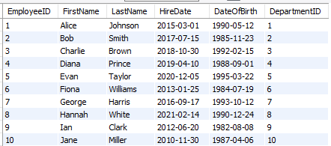

Table 2: Departments Table

DepartmentID INT PRIMARY KEY

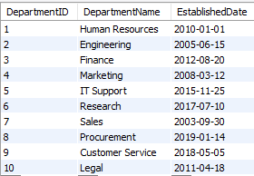

Table 3: Projects Table

ProjectID INT PRIMARY KEY

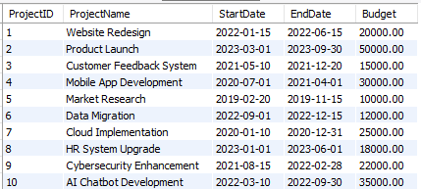

Table 4: **EmployeeProjects Table**

AssignmentID INT PRIMARY KEY

